Lesson Notes: Hierarchical Clustering

Lesson Introduction
Today's Topics & Sequence (Mini Agenda):
- Real-World Problem Hook
- Introduction to Hierarchical Clustering
- Theory Explanation
- Practical Example (Dataset + Step-by-Step)
- Business Scenario / Company Use Case
- Practice Session (5–10 Questions)
- Case Study
- Assignments & Quiz
- Recap

Real-World Hook
Question:
Imagine a company wants to segment its customers to target promotions better, but they do not know how many customer groups exist. How can we automatically group them based on behavior?
Problem:
Traditional segmentation requires predefined groups (K-Means), but the number of natural clusters is unknown.
Solution Introduction:
Hierarchical Clustering can automatically group customers by building a nested cluster tree without specifying the number of clusters upfront.

Introduce Topic as a Solution
Hierarchical Clustering organizes data into a tree structure (dendrogram).
- Helps identify natural clusters in data.
- Works for small to medium datasets.
- Can be visualized easily to understand relationships between clusters.

Theory Explanation

1. What is Hierarchical Clustering?
A clustering method that builds nested clusters either bottom-up (agglomerative) or top-down (divisive).
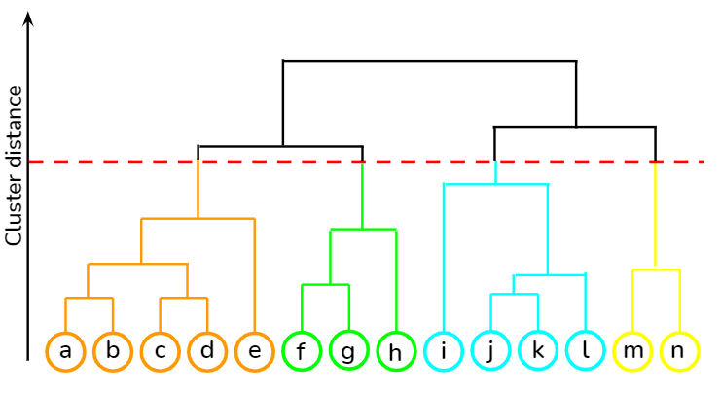
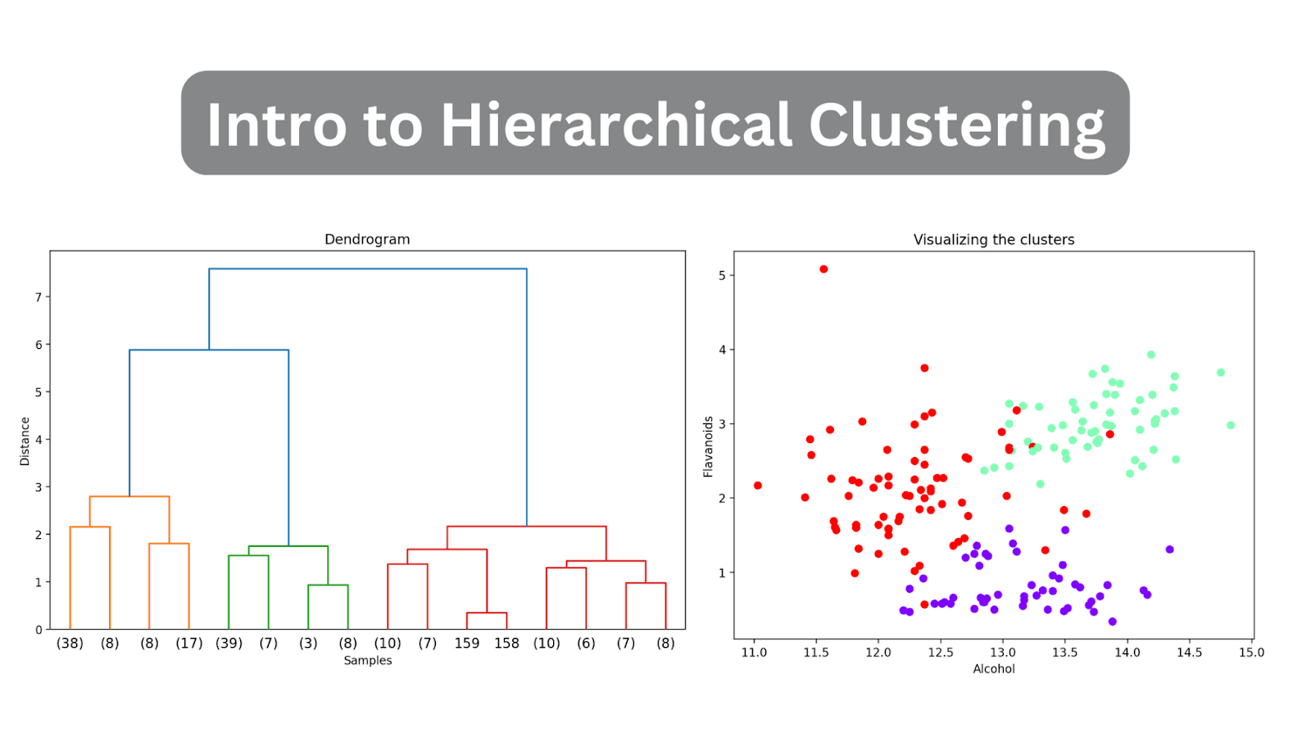

2. Why Use It?
- Identifies natural groupings without predefined cluster count.
- Provides a visual hierarchy of clusters.
- Useful in customer segmentation, medical diagnosis, city planning.

3. When to Use?
- Small to medium-sized datasets
- Unknown number of clusters
- Need visual hierarchy for analysis

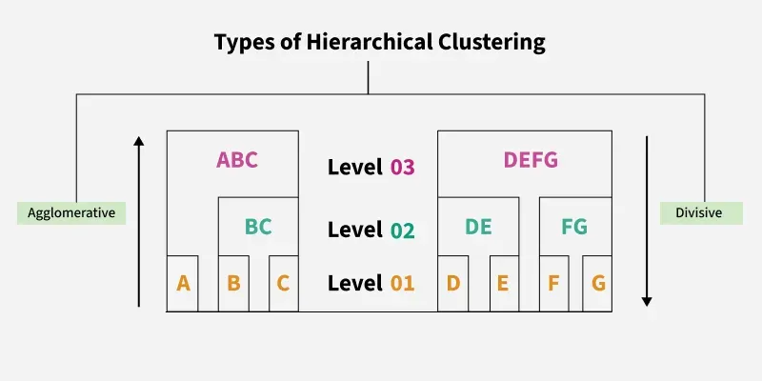

4. How It Works (Step-by-Step Algorithm)
Agglomerative (Bottom-Up):
- Start: Each data point is its own cluster.
- Compute distance between clusters.
- Merge the two closest clusters.
- Repeat until one cluster remains.
- Cut dendrogram at desired level to choose number of clusters.

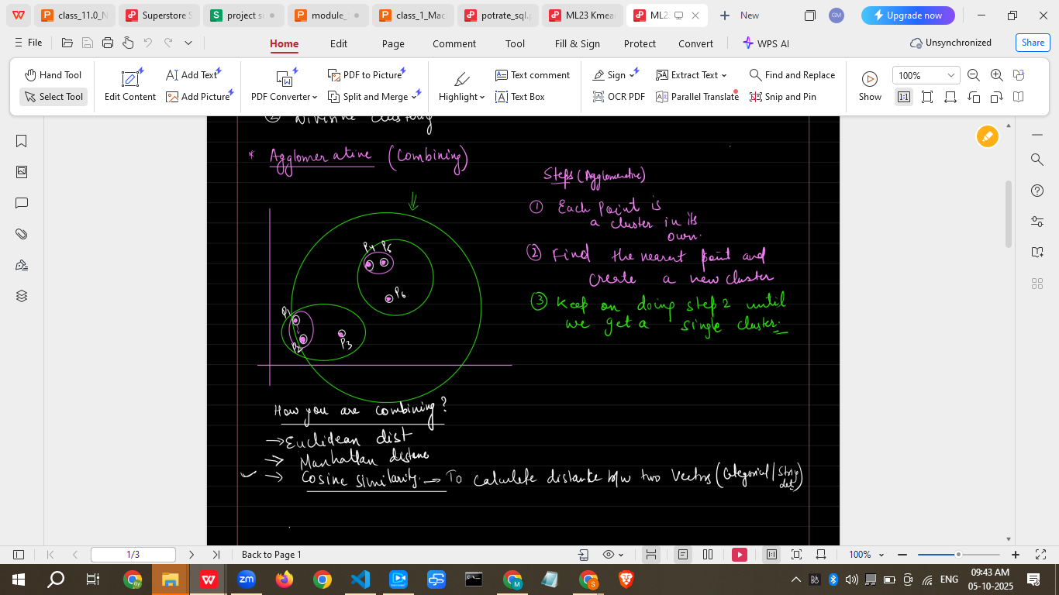
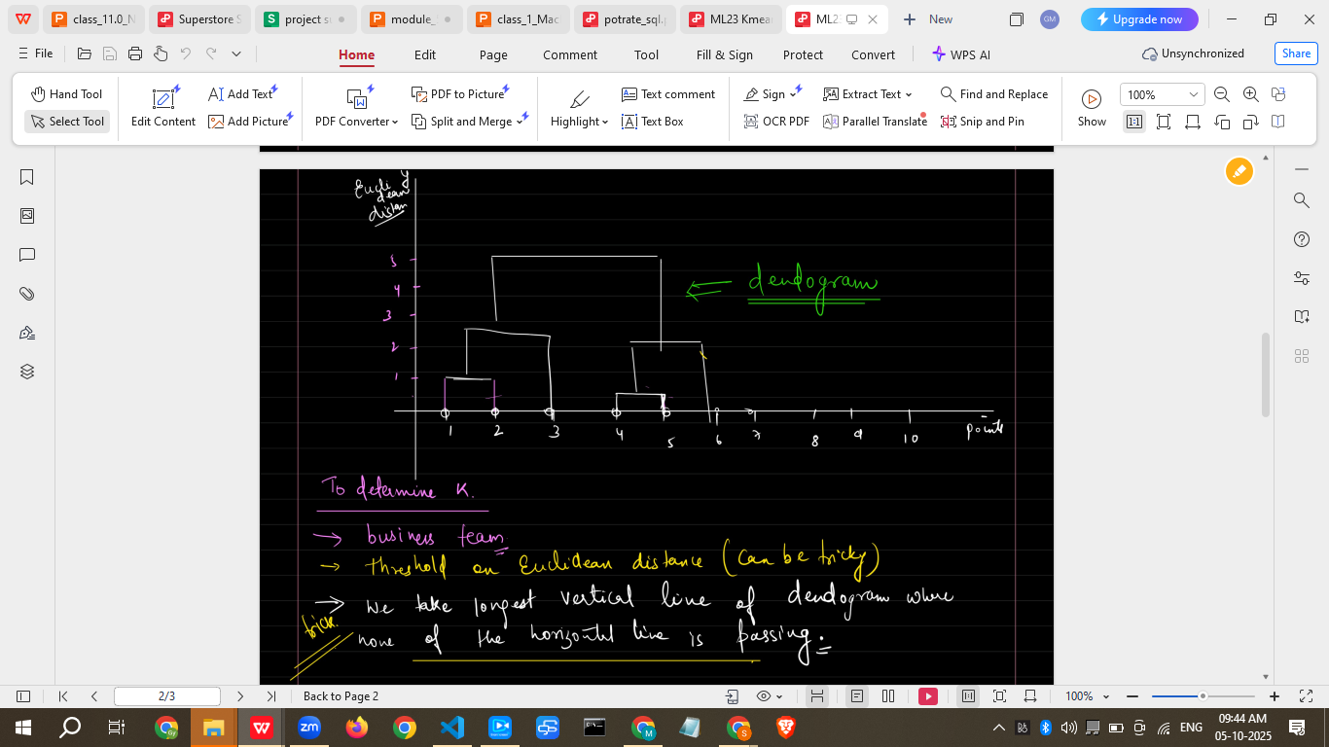
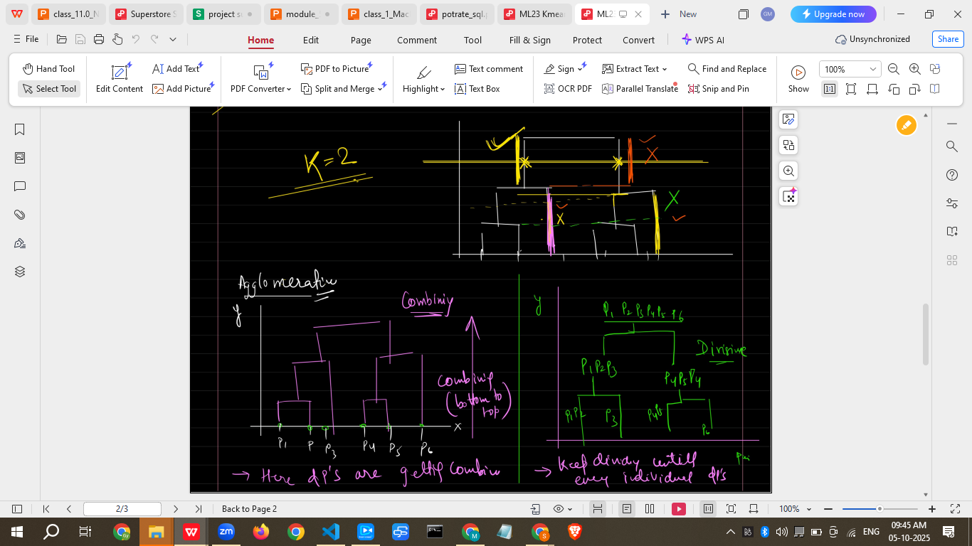

Divisive (Top-Down):
- Start: All data points in one cluster.
- Split cluster into sub-clusters.
- Repeat until each point is a cluster.

5. Linkage Methods

1. What is a Linkage Method?
In hierarchical clustering, linkage methods determine how the distance between clusters is calculated when merging them.
When clustering multiple points into a single cluster, you need a rule to decide which clusters are “closest”. That rule is called the linkage method.
In simple terms:
Linkage = “How do we measure distance between groups of points?”

3. Common Linkage Methods
Linkage Method | How Distance is Calculated | Characteristics & Use Cases
Single Linkage | Minimum distance between points in clusters (nearest neighbor) | Can create “chain-like” clusters; sensitive to outliers
Complete Linkage | Maximum distance between points in clusters (farthest neighbor) | Produces compact, tight clusters; avoids chaining effect
Average Linkage | Average distance between all points in clusters | Balanced method; commonly used for general purposes
Ward’s Method | Minimizes the total variance within clusters | Creates clusters with minimum internal variance; widely used for numerical datasets

How It Works (Step-by-Step)
Example with 3 clusters (A, B, C):
- Single Linkage: Merge clusters with the smallest pairwise distance between any points.
- Complete Linkage: Merge clusters where the farthest points are closest.
- Average Linkage: Merge clusters with smallest average distance between all points.
- Ward’s Method: Merge clusters that increase total variance the least.

Real-World Analogy
- Single Linkage: “Connect the nearest friends first” → may create long chains.
- Complete Linkage: “Connect the farthest friend within the group” → ensures everyone is close together.
- Average Linkage: “Connect clusters by overall closeness” → balanced approach.
- Ward’s Method: “Connect clusters so total disagreement is minimized” → keeps clusters tight and similar.

6. Syntax (Python Example)
from scipy.cluster.hierarchy import dendrogram, linkage
from matplotlib import pyplot as plt

# Sample data
X = [[1,2],[2,3],[5,8],[6,9]]

# Linkage matrix
Z = linkage(X, method='ward')

# Plot dendrogram
plt.figure(figsize=(10, 5))
dendrogram(Z)
plt.show()

7. Advantages & Disadvantages
Advantages:
- No need to predefine clusters
- Provides dendrogram for visualization
- Captures nested cluster structure
Disadvantages:
- Computationally expensive (O(n²))
- Sensitive to noise/outliers
- Not ideal for very large datasets
Limitations & How to Overcome:
- Large datasets → use sampling or K-Means for initialization
- Outliers → preprocess data
Alternative:
- K-Means (fast, needs k)
- DBSCAN (density-based clustering)
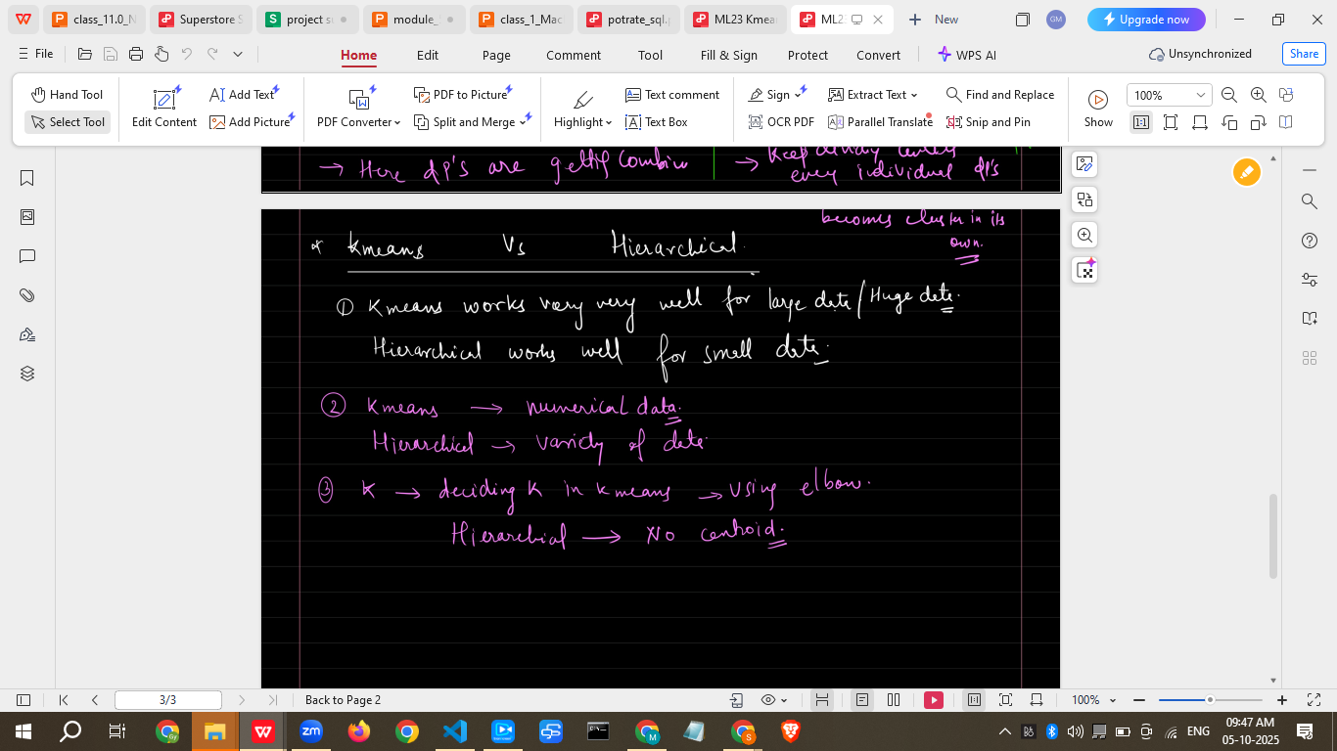

8. Key Characteristics
- Tree-based clustering
- Hierarchical relationships
- Flexible cluster selection

9. When NOT to Use
- Large datasets (>10,000 points)
- High noise or outliers
- When computation time is critical

Practical Example (Dataset + Step-by-Step)
Dataset: Customer Annual Income & Spending Score (50 entries)
CustomerID | Income ($k) | SpendingScore
C1 | 15 | 39
C2 | 16 | 81
… | … | …
C50 | 120 | 90
Step 1: Import libraries & data
import pandas as pd
from scipy.cluster.hierarchy import linkage, dendrogram
import matplotlib.pyplot as plt

data = pd.read_csv('customers.csv') # 50 datapoints
X = data[['Income','SpendingScore']]

Step 2: Create linkage matrix
Z = linkage(X, method='ward')

Step 3: Plot dendrogram
plt.figure(figsize=(12,6))
dendrogram(Z)
plt.title('Customer Dendrogram')
plt.xlabel('Customers')
plt.ylabel('Euclidean distances')
plt.show()

Step 4: Decide clusters → cut dendrogram at desired distance → assign cluster labels

Business Scenario / Company Use Case
Use Case: A retail company wants to identify customer segments for targeted marketing.
How Hierarchical Clustering Helps:
- Segments customers by spending behavior & income
- No need to specify number of segments
- Marketing team can personalize campaigns for each cluster
Example Output:
- Cluster 1 → Low-income, low spending → promotional discounts
- Cluster 2 → Medium income, high spending → loyalty programs
- Cluster 3 → High income, high spending → premium offers

Practice Session (5–10 Questions)
- Create a dendrogram for a dataset of 20 students with scores in Math & English.
- Apply hierarchical clustering to group 30 patients based on symptom severity.
- Identify 3 clusters in a dataset of 50 city locations by population & density.
- Compare Single vs Complete linkage methods for customer data.
- Apply hierarchical clustering on online orders (amount & frequency) and interpret clusters.

Case Study (Mini Project)
Scenario: An e-commerce platform wants to segment users by purchase frequency & average spend.
Task:
- Load dataset (100 users)
- Apply hierarchical clustering using Ward’s method
- Visualize dendrogram
- Assign clusters and provide business recommendations for each segment

Assignments (Optional)
- Compare hierarchical clustering with K-Means on the same dataset.
- Test dendrogram cut at different heights and analyze cluster differences.

Quiz (3–5 Questions)
- What is the main difference between Agglomerative and Divisive clustering?
- Which linkage method is best for minimizing variance?
- How do you determine the number of clusters in hierarchical clustering?
- Mention one advantage and one limitation of hierarchical clustering.
- Why is hierarchical clustering not ideal for very large datasets?

Recap of Today’s Lesson
- Hierarchical clustering groups data without predefining clusters
- Two types: Agglomerative & Divisive
- Output is a dendrogram
- Linkage methods determine cluster distances
- Used in customer segmentation, healthcare, city planning
- Limitations: computationally heavy, sensitive to outliers

Resources for Detailed Learning
- Scipy Hierarchical Clustering Documentation
- Sklearn Agglomerative Clustering
- Hands-On Machine Learning with Scikit-Learn, Keras & TensorFlow – Géron

10 Common Interview Questions (Theoretical)
- What is hierarchical clustering?
- Difference between agglomerative and divisive clustering?
- What is a dendrogram?
- Explain linkage methods.
- How to decide number of clusters?
- Advantages of hierarchical clustering?
- Limitations of hierarchical clustering?
- Difference between hierarchical clustering & K-Means?
- When would you use hierarchical clustering?
- How does outlier affect hierarchical clustering?

10 Common Interview Questions (Practical)
- Plot dendrogram for given dataset.
- Apply hierarchical clustering and assign clusters.
- Compare Single vs Complete linkage.
- Use Python to cut dendrogram at specific height.
- Identify cluster centers (centroids) from hierarchical clustering.
- Apply hierarchical clustering on customer segmentation data.
- Compare cluster results with K-Means on the same dataset.
- Visualize clusters on 2D scatter plot.
- Compute Euclidean distances between clusters.
- Interpret cluster business insights from hierarchical clustering output.

This lesson note is ready to use for non-technical and technical students, including datasets, exercises, business scenarios, and interview prep.

If you want, I can also create a Streamlit app interface where students can upload data, perform hierarchical clustering, visualize dendrograms, and assign clusters — a full interactive learning project.
Do you want me to create that Streamlit interface next?

Here’s a detailed explanation of Linkage Methods in Hierarchical Clustering for your lesson notes:

Linkage Methods in Hierarchical Clustering

1. What is a Linkage Method?
In hierarchical clustering, linkage methods determine how the distance between clusters is calculated when merging them.
When clustering multiple points into a single cluster, you need a rule to decide which clusters are “closest”. That rule is called the linkage method.
In simple terms:
Linkage = “How do we measure distance between groups of points?”

2. Why Linkage Methods are Important
- They control the shape and size of clusters.
- Different methods may produce different dendrograms.
- Help determine how “tight” or “spread out” the clusters are.
- Important for interpreting real-world data correctly.
Example:
- In customer segmentation, choosing the right linkage ensures similar customers are grouped together and dissimilar customers are separated.

3. Common Linkage Methods
Linkage Method | How Distance is Calculated | Characteristics & Use Cases
Single Linkage | Minimum distance between points in clusters (nearest neighbor) | Can create “chain-like” clusters; sensitive to outliers
Complete Linkage | Maximum distance between points in clusters (farthest neighbor) | Produces compact, tight clusters; avoids chaining effect
Average Linkage | Average distance between all points in clusters | Balanced method; commonly used for general purposes
Ward’s Method | Minimizes the total variance within clusters | Creates clusters with minimum internal variance; widely used for numerical datasets

4. How It Works (Step-by-Step)
Example with 3 clusters (A, B, C):
- Single Linkage: Merge clusters with the smallest pairwise distance between any points.
- Complete Linkage: Merge clusters where the farthest points are closest.
- Average Linkage: Merge clusters with smallest average distance between all points.
- Ward’s Method: Merge clusters that increase total variance the least.

5. Real-World Analogy
- Single Linkage: “Connect the nearest friends first” → may create long chains.
- Complete Linkage: “Connect the farthest friend within the group” → ensures everyone is close together.
- Average Linkage: “Connect clusters by overall closeness” → balanced approach.
- Ward’s Method: “Connect clusters so total disagreement is minimized” → keeps clusters tight and similar.

✅ Summary:
- Linkage methods define cluster merging rules in hierarchical clustering.
- Choice affects cluster shape, size, and quality.
- Ward’s method is widely preferred for numerical data.

If you want, I can add a visual dendrogram example comparing Single, Complete, Average, and Ward’s linkage methods so students can see the difference clearly.
Do you want me to create that visual example?

